**Tutorial – JavaScript**

1. Create a JavaScript program to display the date and time of a client computer?

<!DOCTYPE html>

<html>

<head>

<title>Display Date and Time</title>

</head>

<body>

<h1>Date and Time</h1>

<p id="datetime"></p>

<script>

function displayDateTime() {

const now = new Date();

const options = { weekday: 'long', year: 'numeric', month: 'long', day: 'numeric', hour: 'numeric', minute: 'numeric', second: 'numeric', timeZoneName: 'short' };

const formattedDateTime = now.toLocaleDateString('en-US', options);

document.getElementById("datetime").innerText = `Current Date and Time: ${formattedDateTime}`;

}

// Call the function when the page loads

displayDateTime();

</script>

</body>

</html>

1. Using JavaScript enable/disable the embedded video ? (The video should play when the mouse is over the video)

<!DOCTYPE html>

<html>

<head>

<title>Enable/Disable Video</title>

</head>

<body>

<h1>Enable/Disable Video</h1>

<video id="myVideo" width="320" height="240" controls>

<source src="path/to/your/video.mp4" type="video/mp4">

Your browser does not support the video tag.

</video>

<script>

const videoElement = document.getElementById("myVideo");

videoElement.addEventListener("mouseover", () => {

videoElement.play();

});

videoElement.addEventListener("mouseout", () => {

videoElement.pause();

});

</script>

</body>

</html>

1. Write a JavaScript function to add rows to a table.

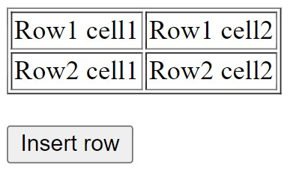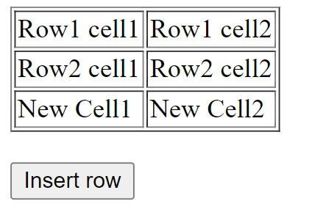

1. Write a JavaScript program to remove items from a dropdown list.

Program.html code

<!DOCTYPE html>

<html>

<head>

<title>Remove Items from Dropdown List</title>

</head>

<body>

<label for="dropdownList">Select an item to remove:</label>

<select id="dropdownList">

<option value="1">Item 1</option>

<option value="2">Item 2</option>

<option value="3">Item 3</option>

<option value="4">Item 4</option>

<option value="5">Item 5</option>

</select>

<button onclick="removeSelectedItem()">Remove Selected Item</button>

<script src="script.js"></script>

</body>

</html>

Program.js code

function removeSelectedItem() {

const dropdownList = document.getElementById('dropdownList');

// Get the index of the selected option

const selectedIndex = dropdownList.selectedIndex;

// Check if any option is selected

if (selectedIndex !== -1) {

// Remove the selected option from the list

dropdownList.remove(selectedIndex);

} else {

alert('Please select an item to remove.');

}

}

1. Write a JavaScript program to change the border of a table.

Program.html code

<!DOCTYPE html>

<html>

<head>

<title>Change Table Border</title>

<style>

/* Default table border */

table {

border-collapse: collapse;

border: 1px solid black;

}

/* Additional CSS for demonstration purposes */

th, td {

padding: 8px;

text-align: center;

border: 1px solid black;

}

</style>

</head>

<body>

<button onclick="changeTableBorder()">Change Table Border</button>

<table id="myTable">

<tr>

<th>Header 1</th>

<th>Header 2</th>

<th>Header 3</th>

</tr>

<tr>

<td>Cell 1</td>

<td>Cell 2</td>

<td>Cell 3</td>

</tr>

<tr>

<td>Cell 4</td>

<td>Cell 5</td>

<td>Cell 6</td>

</tr>

</table>

<script src="script.js"></script>

</body>

</html>

Program.js code

function changeTableBorder() {

const myTable = document.getElementById('myTable');

const currentBorderStyle = myTable.style.border;

if (currentBorderStyle === '') {

// If the border is currently not set, change it to the desired style

myTable.style.border = '2px solid red';

} else {

// If the border is already set, remove it

myTable.style.border = '';

}

}